South African Council
for the Architectural Profession

PROFESSIONAL PRACTICE EXAMINATION
OCTOBER 2022

PAPER 1

- Candidates are required to answer ALL the questions.
- Questions must be answered in SEQUENCE. Ensure that your answers are clearly NUMBERED.
- This is a CLOSED BOOK paper. No notes, supplementary documents or online referencing is permitted.
- All answers must be in your OWN words where appropriate.
- Where answers are duplicated between candidates, plagiarised, or copied, ZERO marks will be granted.
- Take note that duplicated, plagiarised and/or copied answers may be subject to further investigation, penalties and/or disciplinary action.
- Total marks for paper one – 150 marks
- Pass mark – a minimum of 50% in each of the two papers
- Time allocation – 3 hours

QUESTION 1 20 marks

1.1 | Provide the definition of the phrase "deemed to satisfy" as used in the context of the National Building Regulations and Building Standards Act. | (3)
1.2 | Provide the definition of the word "accredit" as a function of the South African Council for the Architectural Profession (SACAP). | (4)
1.3 | Provide the definition of "principal consultant" when used in the context of architectural services. | (4)
1.4 | Provide the definition of a "building line". | (3)
1.5 | Provide the definition of the word "reasonable" as it is used in the following sentence:  The architectural professional accepts the appointment to exercise reasonable professional skill, care and diligence in the performance of obligations, for a fee as defined in a written agreement. | (6)

QUESTION 2 10 marks

Select the correct answer to the following questions by providing only the corresponding letter(s).

2.1 | The primary mandate of the South African Council for the Architectural Profession (SACAP) is to protect which of the following groups? |  | (2)
 | Select ONE (1) from the following list (2 marks)
 | A | The architectural profession
 | B | The construction industry
 | C | The local municipalities
 | D | The public
 | E | The education system
2.2 | The SACAP Identification of Work for the Architectural Profession was specifically drafted for which of the following professionals? |  | (2)
 | Select ONE (1) from the following list (2 marks)
 | A | Draftspersons
 | B | Architectural Technologists
 | C | Senior Architectural Technologists
 | D | Architects
 | E | All of the above
2.3 | Which of the follow professional service agreements was compiled to specifically include work stage ZERO (0)? |  | (2)
 | Select ONE (1) from the following list (2 marks)
 | A | SACAP Client-Professional Project Agreement for Architectural Services
 | B | SAIA Client-Architect Agreement
 | C | PROCSA Client/Consultant Professional Services Agreement
 | D | JBCC Principal Building Agreement
 | E | JBCC Minor Works Agreement
2.4 | A client has prepared an agreement to use with an architectural professional. To minimise the risk, which of the following should the architectural professional ensure is included in the agreement? |  | (2)
 | Select TWO (2) from the following list (1 mark each)
 | A | A penalty amount for delays in the provision of architectural services
 | B | Client's obligation to provide copies of documentation containing site information
 | C | Architectural professional's warranty of the performance of the building
 | D | Architectural professional's warranty of local authority approval
 | E | Client's authority to the architectural professional to act as the client's agent when carrying out architectural services
2.5 | The South African Council for the Architectural Profession develops and promotes architectural education. |  | (2)
 | Select ONE (1) from the following list (2 marks)
 | A | TRUE
 | B | FALSE

QUESTION 3 35 marks

Mr and Mrs Singh were looking for an existing house to purchase with the intent of carrying out some additions and alterations. Having found a house in Umhlanga that they thought would be suitable, the Singh's approached Mr Adam Crooks, a local professional architectural technologist, for advice.
After visiting the property with the Singhs, Mr Crooks did a quick sketch layout and compiled a cost estimate for the project, which amounted to approximately R 1,500,000.00 (excluding VAT and professional fees). Based on this, the Singhs bought the existing house and asked Mr Crooks to compile a fee proposal for his standard (full) scope of architectural services.
3.1 | Using the following extract for a medium complexity building from the current SACAP Guideline for Professional Fees (Board Notice 307 of 2022), calculate the project cost-based fees to provide the standard (full) scope of architectural services for this project based on the budget of R 1,500,000.00 (excluding VAT and professional fees). | (14)
 | Present your calculation by providing the information required in the following table (mark allocations are indicated):

TABLE 2: Medium Complexity
MEDIUM COMPLEXITY
Cost  Bracket | Value of works |  | Primary Fee | Plus, secondary fee
 | From | To |  | Add % | On balance over
 | A | B | C | D | E
1 | 1.00 | 200 000.00 | 12 240.00 | 18.91% | 1.00
2 | 200 001.00 | 650 000.00 | 50 067.17 | 18.18% | 200 001.00
3 | 650 001.00 | 2 000 000.00 | 131 870.39 | 13.41% | 650 001.00
4 | 2 000 001.00 | 4 000 000.00 | 312 886.84 | 11.69% | 2 000 001.00
5 | 4 000 001.00 | 6 500 000.00 | 546 673.78 | 11.38% | 4 000 001.00
6 | 6 500 001.00 | 13 000 000.00 | 831 246.74 | 9.88% | 6 500 001.00
7 | 13 000 001.00 | 40 000 000.00 | 1 473 440.14 | 9.56% | 13 000 001.00
8 | 40 000 001.00 | 130 000 000.00 | 4 052 809.42 | 9.55% | 40 000 001.00
9 | 130 000 001.00 | 260 000 000.00 | 12 645 330.47 | 8.94% | 130 000 001.00
10 | 260 000 001.00 | 520 000 000.00 | 24 255 571.57 | 8.73% | 260 000 001.00
11 | 520 000 001.00 | 1 040 000 000.00 | 46 946 264.55 | 8.51% | 520 000 001.00
12 | 1 040 000 001.00 |  | 91 173 895.32 | 7.86% | 1 040 000 001.00

PROJECT COST-BASED FEES  FOR ARCHITECTURAL SERVICES |  |  |  | mark
TOTAL FEES (excl. VAT) |  |  |  | (2)
VAT at 15% |  |  |  | (0.5)
TOTAL FEES (incl. VAT) |  |  |  | (1)
APPORTIONMENT OF PROJECT COST-BASED FEES
FOR ARCHITECTURAL SERVICES PER WORK STAGE
STAGE | FEE (excl. VAT) | mark | FEE (incl. 15% VAT) | mark
1. |  | (1) |  | (0.5)
2. |  | (1) |  | (0.5)
3. |  | (1) |  | (0.5)
4.1. |  | (1) |  | (0.5)
4.2. |  | (1) |  | (0.5)
5. |  | (1) |  | (0.5)
6. |  | (1) |  | (0.5)

Without further inspections of the property, Mr Crooks presented his fee proposal and Mr and Mrs Singh agreed for him to proceed with the project. The Singhs paid Mr Crooks' invoices up to and including work stage 3, despite the fact that there was no written agreement in place. After completion of work stage 4.1 and the approval by the local authorities, Mr Crooks identified three contractors to tender for the project.
The lowest tender amount was R 2,750,000.00 (excluding VAT) – much more than the initial estimate. The Singh's were understandably concerned and Mr Crooks informed them that his estimate was not precise as it was based on the initial design sketch. After this, Mr Crooks presented a new invoice for the work carried out until completion of work stage 3 based on the lowest tender amount.
Mr and Mrs Singh did not pay the last invoice received from Mr Crooks and decided to sell the property. Due to the fact that the submission for the additions and alterations were approved by the local authority, they were able to make a profit on the sale. The Singhs have now received a letter from Mr Crooks who informs them that he has referred the matter of his unpaid last invoice to his attorneys.
Mr and Mrs Singh now regard the actions of Mr Crooks as improper conduct by a registered architectural professional.
3.2 | Identify and describe THREE (3) ways in which you would have provided your services as an architectural professional in order to avoid the current situation in this scenario (4 marks each – 12 marks total).
 | 1. | answer ONE | (4)
 | 2. | answer TWO | (4)
 | 3. | answer THREE | (4)
3.3 | What action could Mr and Mrs Singh consider taking against Mr Crooks as a result of this situation? |  | (3)
The new owners of the property would like to complete the additions and alterations project based on the approval by the local authorities.
3.4 | 1. | Identify whether this either would or would not be possible. | (2)
 | 2. | Provide a reason for your answer. | (4)

QUESTION 4 24 marks

You have been working as a candidate architectural professional for a small practice in Kimberley and recently successfully completed your SACAP Professional Practice Exam. Your employer, Mr Holmes, has sent you the following email:
"Dear Ms. Watson,
As you know, Ngwale Developments have recently declared bankruptcy. Take-Over Properties (one of our previous clients) bought one of their former sites just outside of Upington. There is local authority approval in place for a residential development of 120 new units based on a tight layout with six different unit types that were developed with plans, sections and elevations.
I was told that Ngwale Developments did not pay the professional team for the project, as they believed that the architect's fees were exorbitant. Apparently, their fees was for the standard (full) scope of architectural services and were in accordance with the latest SACAP Fee Guidelines. Mr Bright from Take-Over Properties also does not wish to be involved with the members of that professional team either.
We have done some good work with Take-Over in the past, and Mr. Bright has asked our practice to proceed with work stage 4.2 and complete the project as soon as possible. I am in the process of writing a letter to send to him. As you have recently passed your SACAP Professional Practice Exam, please refresh my memory by answering the following (see questions 4.1 to 4.5 below):
Yours sincerely,
Sherlock"
4.1 | "How would the previous architect have calculated their fees for this project?" |  | (6)
4.2 | "If we agree to provide the standard scope of architectural services, describe our obligations during the following work stages:"
 | 1. | Work stage 4.2 (1 mark per obligation – 5 marks total) | (5)
 | 2. | Work stage 5 (1 mark per obligation – 5 marks total) | (5)
4.3 | "If we decide to carry on with the project, what must be done about the issue of copyright?" |  | (4)
4.4 | "Take-over Properties have their own contract that is used for all professional consultants. What is the most important aspect of the contract must I ensure is included in order to protect our practice in the long term?" |  | (4)

QUESTION 5 26 marks

Thelma has recently established her own architectural practice based in Midrand, Gauteng. A week ago, Thelma met up with Louise, and old school friend who has recently qualified as a quantity surveyor and has decided to settle in Pretoria.
Louise knows of a project that entails the construction of an eight-storey apartment building on an empty site in Gqeberha in the Eastern Cape. The client (a Gauteng-based developer known as Roller-Coaster 3000) would like to explore the idea of making use of a multi-disciplinary consortium of built environment professionals. Mr Fine from Roller-Coaster would like to have a meeting to discuss some of the some of the options of how to proceed with this project.
5.1 | Aside from Thelma (as architectural professional and principal consultant) and Louise (as quantity surveyor and principal agent), identify FOUR (4) other types of built environment professionals that would be essential for the multi-disciplinary consortium on this project (1 mark each – 4 marks total). |  | (4)
5.2 | Describe what Thelma and Louise should consider as part of each of the following aspects of a multi-disciplinary consortium:
 | 1. | Invoicing and Payment | (3)
 | 2. | Disbursements | (3)
 | 3. | Interim Fees | (3)
 | 4. | Professional Indemnity insurance | (3)
Thelma, Louise and Roller-Coaster 3000 are all based in Gauteng while the project is located in the Eastern Cape. Mr Fine from Roller-Coaster 3000 is comfortable to go ahead with the project without the services of a project manager.
5.3 | 1. | Which alternative person could Thelma and Louise nominate to interact with the contractor in Gqeberha during the construction stage? | (2)
 | 2. | Who would be responsible to appoint and pay for the services of this person? | (2)
 | 3. | Identify TWO (2) of the services that this person would provide (3 marks each – 6 marks total). | (6)

QUESTION 6 10 marks

6.1 | Identify THREE (3) ways in which an architectural professional can ensure that the need for changes on a project may be minimised (2 marks each – 6 marks total). | (6)
6.2 | Discuss the meaning of the phrase "Duty of Care" in relation to architectural services. | (4)

QUESTION 7 25 marks

The following THREE (3) drawings are being prepared for local authority approval in Knysna in the Eastern Cape. The project entails additions and alterations that includes a new double garage plus a staircase to a new first floor guest bedroom over part of the existing single storey residential structure.
7.1 | Refer to Drawing 7.1: Extract from SITE Plan below
 | 1. | What is the name of the document that would indicate the building lines on the property? | (3)
 | 2. | What will be required in order for the new structure to be constructed over the building line? | (3)
 | 3. | Name the existing structure that was constructed over the building line. | (3)

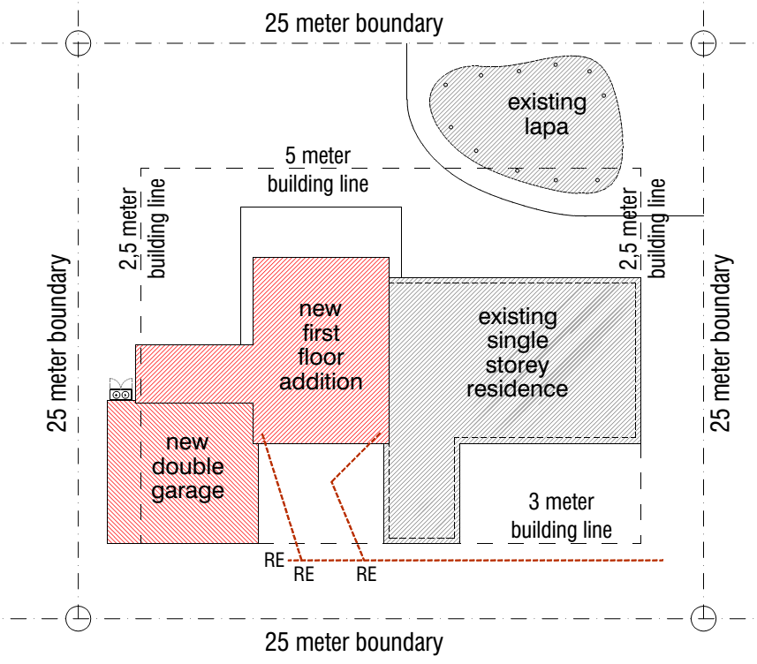
Drawing 7.1: Extract from SITE Plan

7.2 | Refer to Drawing 7.2: Extract from GROUND Floor Plan below
 | Identify FIVE (5) errors that have been made in terms of the South African National Standards (SANS) 10400 (2 marks each – 10 marks total). | (10)

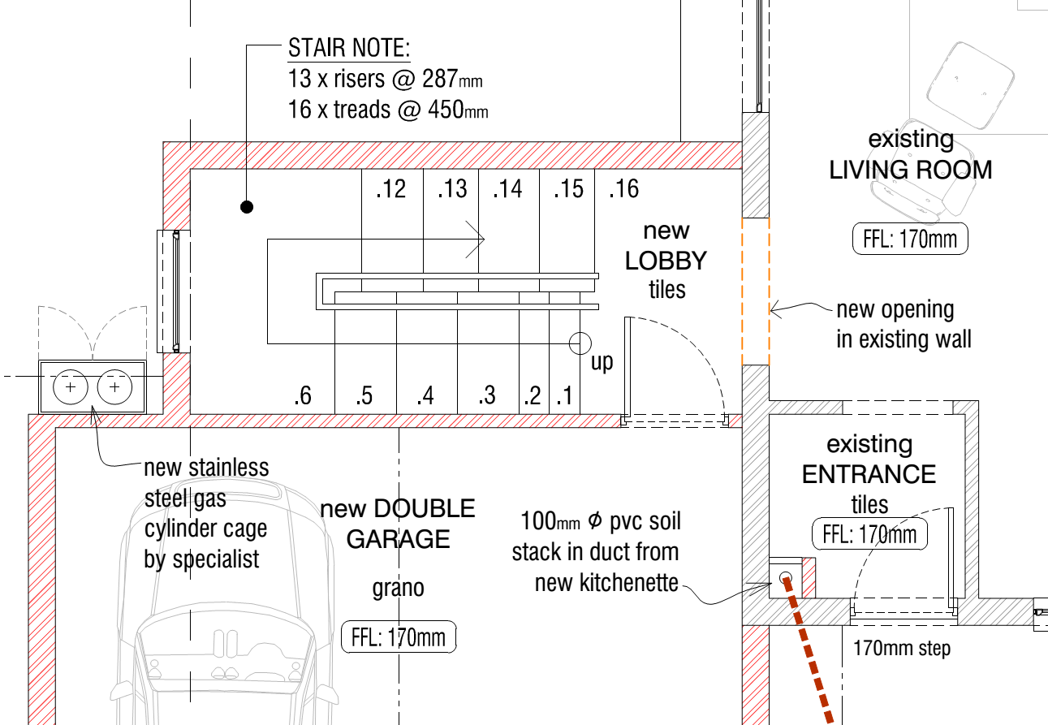
Drawing 7.2: Extract from GROUND floor plan:

7.3 | Refer to Drawing 7.3: Extract from FIRST Floor Plan below:
 | Describe the reasons why the following is in contravention of the South African National Standards (SANS) 10400:
 | 1. | Swing of the door from the landing. | (2)
 | 2. | Gas hob. | (2)
 | 3. | Plumbing from the sink, shower, wash hand basin (whb) and bath. | (2)

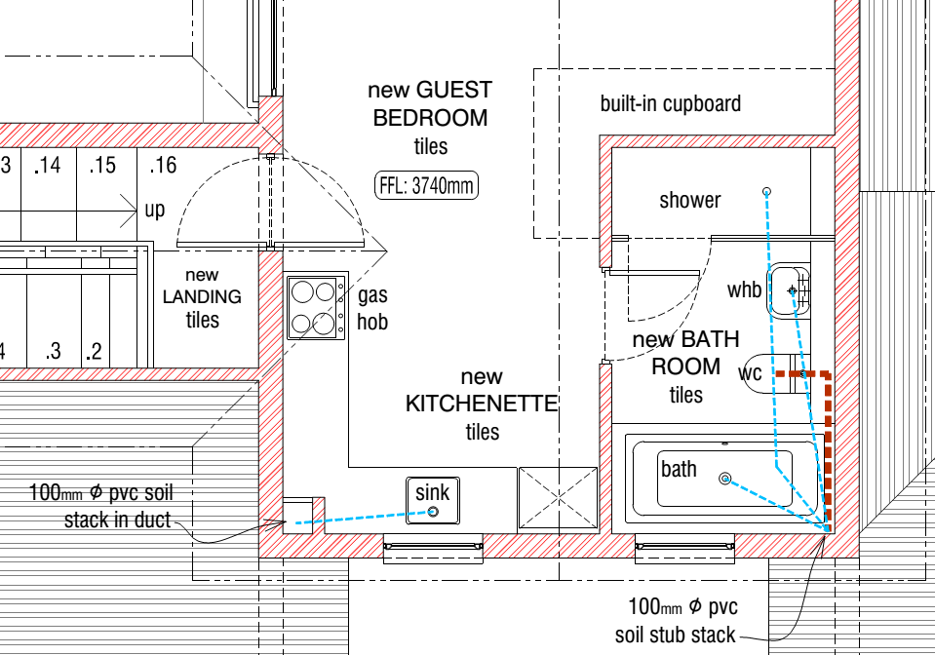
Drawing 7.3: Extract from FIRST floor plan:

end of examination paper one

